- Login to Promox and open console
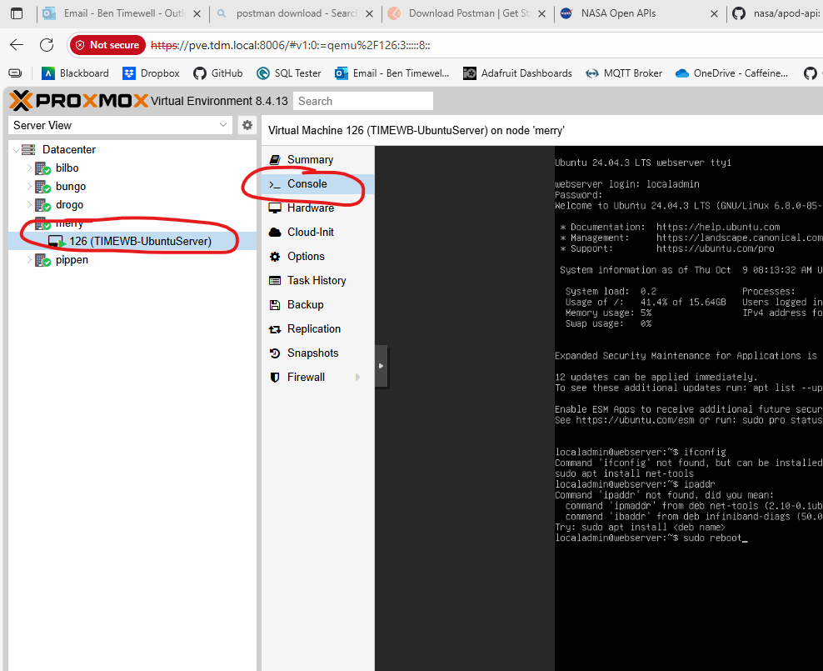

- When Promox boots, wait for Promox UI to disappear, then spam ESC key. You only have a half second window. Otherwise, reboot and try again.
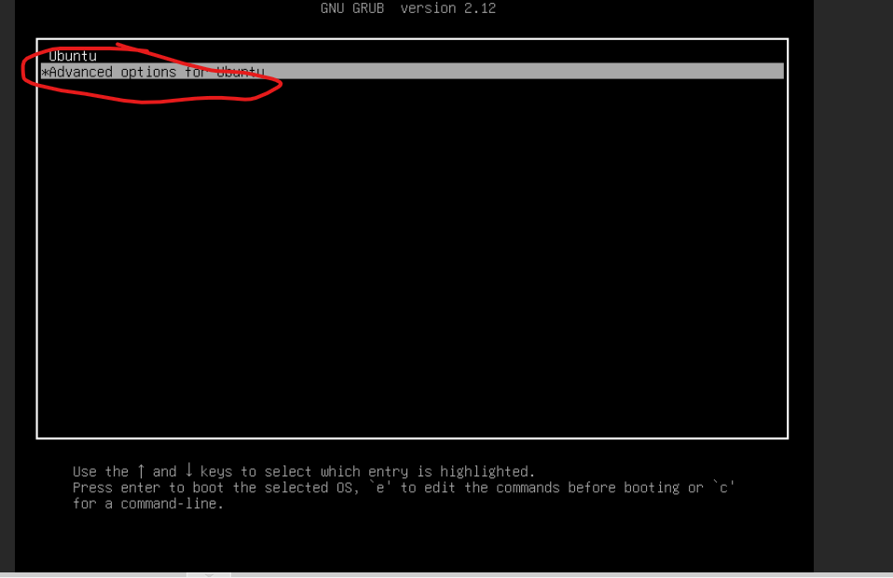
- If you managed to land the quick ESC key, the above menu will appear. Arrow down to “Advanced options” and press enter
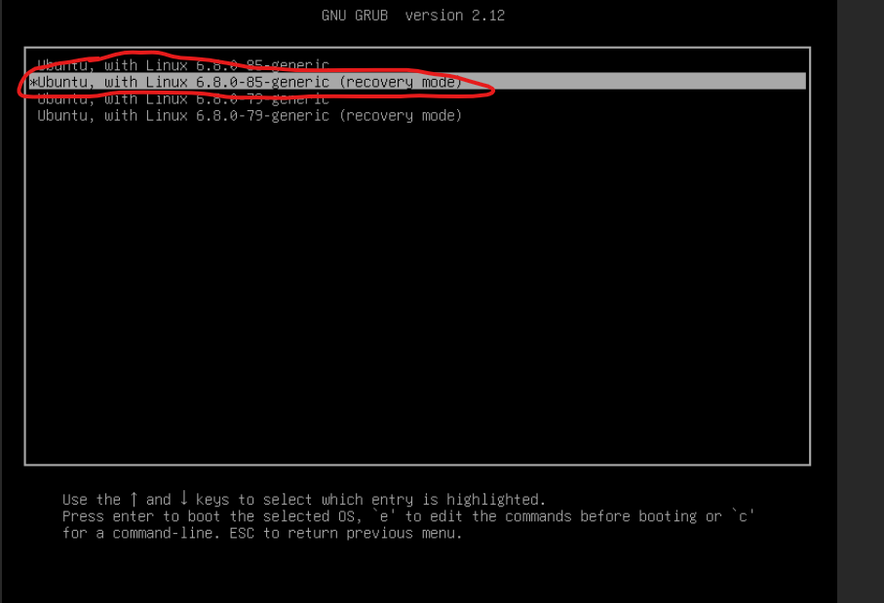
- Select the highest version number with (recovery mode), and press enter
- Select “enter into root shell” (sometimes the screen will bug out and show the below. Just arrow down until you see “Root – Drop to root shell prompt” and press enter
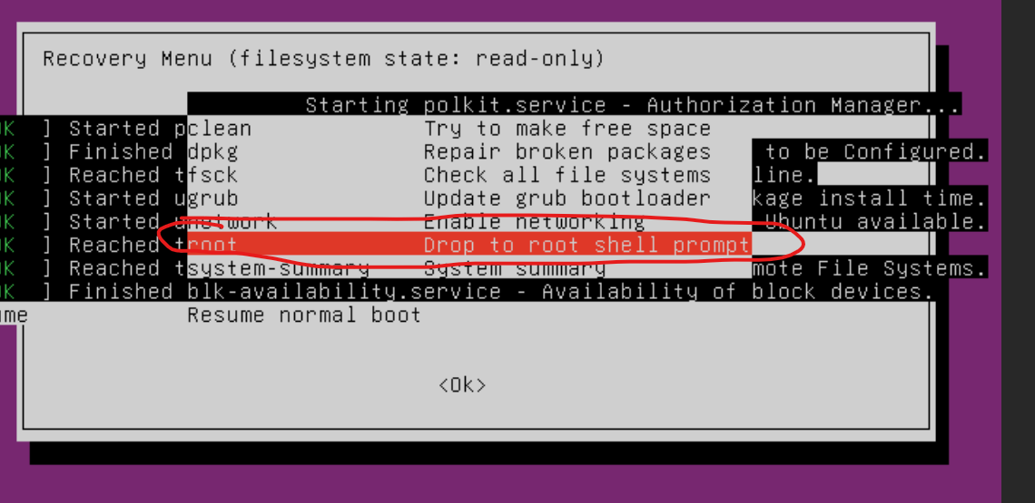

- You’ll be asked to enter “maintenance mode”. Hit enter to contain, you’ll then be greeted with a shell (may look slightly different):
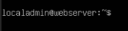
- Enter command: “passwd localadmin”
- Enter new password, then again to confirm
- Reboot VM (either sudo reboot command, or from the top “shutdown” dropdown menu
- After reboot, hit enter to boot into “Ubuntu”
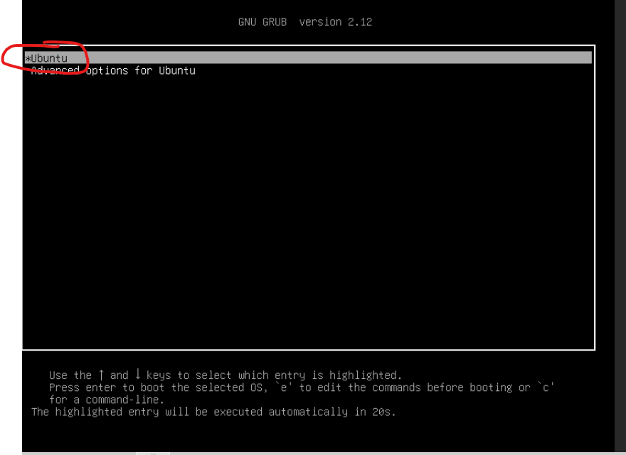
- Login with new password set earlier

